Analysis and Experimental Validation of SSTDR for Simultaneous Distributed Diagnosis of Wire Networks

Mouad Addad, *Member, IEEE*, Ali Djebbari, Evan Benoit, and Cynthia M. Furse, *Fellow, IEEE*

|  |
| --- |
|  |
| ***Abstract*— Reflectometry-based techniques such as Spread Spectrum and Sequence Time Domain Reflectometry (SS/STDR) have been extensively used for the detection, localization, and characterization of electric faults in wires. However, in branched wire networks, testing using a single sensor suffers from ambiguity where it can be difficult to determine which branch contains the fault. Distributed reflectometry, which uses multiple sensors to test the network from different locations, can resolve this ambiguity. This paper evaluates pseudo-noise (PN) and zero correlation zone (ZCZ) codes for simultaneous distributed testing, Maximum length (ML or *m*-), Gold and zero correlation zone (ZCZ) codes are compared for a set of up to 16 simultaneous sensors. ML and Gold codes show significant interference between sensors, but the ZCZ codes show near-zero interference over their measurement zone.** **This lack of interference greatly enhances their use for locating small faults.** **The results were verified numerically and validated experimentally.**  ***Index Terms*—** spread spectrum time domain reflectometry (SSTDR), Sequence time domain reflectometry (STDR), distributed reflectometry, non-destructive evaluation, fault location, wire networks, simultaneous testing, continuous diagnosis. |
|  |

# Introduction

Wired networks are ubiquitous wherever the transfer of energy and information is needed. They can be found in aircraft, cars, buildings, railways, nuclear power plants, and more. Electrical faults in these systems plague maintainers, driving the need for health monitoring tools able to detect and accurately locate faults. Reflectometry is a powerful technique that has been used extensively for the detection, localization, and characterization of electrical faults [1]. A test signal is injected into the wire, and part of its energy is reflected back to the injection point when it encounters impedance discontinuities within the wire. The test device then extracts information about the location and the nature of these discontinuities from the reflected signal. If the topology of the network is branched, reflections come back from each junction and end of each branch, resulting in multiple, often over-lapping, reflections that can lead to ambiguities. If the network has two equal-length arms, one of which has a fault, it is impossible to determine which of the arms is faulty from a single sensor [1], [2], [3], [4]. If an open circuit and a short circuit, which have equal and opposite reflections, are at the same distance from the sensor, their reflections cancel each other out, and neither can be located from a single sensor. Furthermore, the impedance discontinuity between the wire and reflectometer causes an immediate reflection, which results in a “blind zone” in which faults close to the injection point are overshadowed by this reflection. Another challenge for branched networks is that each junction reflects some of the transmitted energy, thus reducing the reflection that returns to the tester. This limits the number of junctions a single tester can see through before the signal is below its detection threshold. [4]. The attenuation on long wire lengths exacerbates this problem.

To solve the problems with testing branched networks from a single location, distributed reflectometry uses multiple sensors placed at various points on the wire network [1], [2], [4]. Each sensor provides a different perspective on the network topology. The aggregation of information from all sensors allows the removal of fault location ambiguities and blind zones and allows the testing of longer and more complex networks. Many algorithms have been developed for network evaluation with reflectometry including the Greedy algorithm [5], iterative calculations [3], [6], reverse image searching [7], removing the pulses from nodes [8], selective averaging [2], wavelet transforms [9], [10], support vector machines [11], sensor fusion [12], genetic algorithm [13], [14], residual voltage inversion [15], time reversal [16], and more.

Cindy is working next here … This can be accomplished in two ways. At first glance, activating each sensor one at a time may seem like a good way to prevent interference between them. However, this means that only a portion of the system is being tested at any given time, and intermittent faults can be missed during this time. For continual testing and monitoring, which we will focus on, each sensor should test continually and simultaneously. In this case, signals from the sensors need to be chosen so that they do not interfere with each other.

A reflectometry-based measurement technique, such as time domain reflectometry (TDR), uses a step or pulsed incident signal, whereas noise domain reflectometry (NDR) uses existing noise and signals in the system as a passive test system. These techniques are not suitable for testing multiple channels simultaneously, as they would interfere with each other. Testing multiple channels simultaneously requires multiple orthogonal signals. This can be accomplished with spectral time domain reflectometry (STDR) and spread spectrum time domain reflectometry (SSTDR).

In this paper, we focus on enabling distributed sensing and diagnosis of branched wire networks using S/SSTDR [17], with zero-correlation codes (ZCZ). The advantage of these codes is that they do not interfere with each other over a specific zone (in time or space), which can greatly improve testing accuracy. This has been previously introduced in [18], [19], [20]. In this paper, we validate these results with measurement and simulation on a Y-shaped branched network. We compare *m*-, Gold, and ZCZ sequences to determine how much interference will be seen with up to 16 sensors working simultaneously (which gives 15 interferers for each sensor).

This paper is organized as follows. Section II describes the analytical model of the distributed diagnostic system. Section III discusses the selection of suitable ZCZ signals that provide interference-free measurements. Experimental validation is conducted in Section IV. Simulation is described in Section V to verify the analytical results. The discussion and conclusion in Section VI describes how to adapt these results to other systems.

# System Model

A block diagram of and S/SSTDR system for testing a wire network from multiple locations (distributed sensing) is shown in Fig. 1. A single sensor is shown, but additional sensors may be present at other points of the network.

SS/STDR

Correlator

Fig. 1. Block diagram of an SS/STDR system.

An STDR test signal consists of a square wave modulated by a sequence as in

|  |  |
| --- | --- |
| $$s_{i}\left(t\right)=\sum_{n=-∞}^{∞}{s_{i,n} p\left(t-nT_{c}\right)}$$ | (1) |

where sequence $s_{i,n}∈\left\{-1,1\right\}$ has a chip width, $T_{c}$, and the rectangular pulse waveform $p\left(t\right)$ is defined as

|  |  |  |
| --- | --- | --- |
| $$p\left(t\right)=\left\{\begin{aligned}1 \\ 0\end{aligned}\right.$$ | $$0≤t≤T_{c}$$ | (2) |
| otherwise |

Note that $s_{i}\left(t\right)$ is a periodic signal with period $T=NT_{c}$, where *N* is the sequence length, so that $s_{i}\left(t\right)=s_{i}\left(t+T\right)$. After transmission onto the wire network, the received signal at the $i^{th}$ sensor is

|  |  |  |
| --- | --- | --- |
|  |  |  |
|  |  | () |

where is the amplitude of the reflection at the testing point due to the impedance mismatch between the measurement device and the wire, $a_{p}$ and $τ_{p}$ are, respectively,the attenuation coefficients and delays of the test signal $s_{i}\left(t\right)$ coming back from an unknown number *p* of impedance mismatches in the wire network, $d\left(t\right)$ is the data signal on the network, $b_{k}$ and $τ_{k}$ are, respectively, the attenuation coefficients and delays of a different test signal, $s_{k}\left(t\right),$ coming from the $k^{th}$ sensor, and $n\left(t\right)$ is the noise signal.

The reflected signal carries information about the status of the wire network, and many algorithms are available to extract the network topology, detect and locate faults, etc. [1]. Interference caused by the signals from all sensors working simultaneously, data signals, and noise can perturb the received signals. The effects of noise can be reduced through averaging and other de-noising techniques [18] (Comment 2 from Reviewer 2. We suggest two responses: either add more references on reducing noise or include a correlation term for the noise in equations (6) and (12)). In this paper, we will focus on choice of sequences to reduce interference from multiple sensors transmitting and receiving simultaneously.

For STDR, the received signal is cross correlated with a reference signal, typically the incident signal. Signals testing continuously are periodic, so the periodic cross correlation function is used:

|  |  |
| --- | --- |
| $$R_{rs_{i}^{'}}\left(τ\right)=\frac{1}{T}\int_{0}^{T}{s_{i}^{'}\left(t\right) r\left(t+τ\right) dt}$$ | (4) |

where $s_{i}^{'}\left(t\right)$ is the reference (incident) signal. The delay $τ$ is proportional to the distance $d$ over which the signal is delayed:

|  |  |
| --- | --- |
| $$2 d=v τ$$ | (5) |

where $v$ is the velocity of propagation (VOP) on the wire, and the 2 comes from the wire traveling to and from the fault. The magnitude of the correlation in (4) depends on the length of the signals and how well correlated they are, and is called the correlation amplitude we will show in Fig. 2. We will use this correlation, to evaluate more complicated systems, as well. By substituting (3) in (4), we obtain the correlation of the complete received signal

|  |  |  |
| --- | --- | --- |
|  |  |  |
|  |  | () |

Equation (6) shows that the correlator’s output depends on the correlation properties of the incident sequence. To further clarify this point, let’s rewrite the first term of (6) as follows

|  |  |  |
| --- | --- | --- |
|  | | |
|  |  | () |

The integral in (7) is nonzero only when $p\left(t-mT_{c}\right)$ and $p\left(t+τ-nT_{c}\right)$ overlap. The delay $τ=lT_{c}+τ_{ϕ}$, where $0≤τ_{ϕ}<T_{c},$ is any delay, not necessarily an integer number of chips. Using this substitution, the pulses overlap only for $n=m+l$ and $n=m+l+1$, so that (7) becomes

|  |  |  |
| --- | --- | --- |
|  |  | () |

The discrete periodic cross correlation function (PCCF) of two sequences $s_{k}$ and $s_{i}^{'}$ is defined as

|  |  |
| --- | --- |
| $$E_{s_{k}s_{i}^{'}}\left(l\right)=\frac{1}{N}\sum_{n=0}^{N-1}{s_{k,n}s_{i,n+l}^{'} }$$ | (9) |

where the subscript $n+l≥N$ is computed modulo $N$. When $k=i$, the PCCF becomes the periodic autocorrelation function (PACF). Similarly, it can also be shown that the autocorrelation of one of the reflections in (6) with a delay mouad please help this doesn’t look right>> *τp* from the wire network is

|  |  |  |
| --- | --- | --- |
|  | | |
|  |  | () |

and a similar cross correlation between reference and an interference signal in (6) is

|  |  |  |
| --- | --- | --- |
|  | | |
|  |  | () |

Note that in the special case where reference and reflection signals are shifted by an integral number of chips, $τ=lT_{c}$, Equation (6) becomes

|  |  |  |
| --- | --- | --- |
|  |  |  |
|  |  | () |

A similar expression was obtained in [18] where $R_{rs_{i}^{'}}\left(τ\right)$ is dependent on the *aperiodic* correlation properties. In contrast, (12) depends on the *periodic* correlation properties. Also, similar results can be obtained for spread spectrum time domain reflectometry (SSTDR), which uses a sine wave (or other function) modulated by the STDR signal. The performance of the diagnostic system is improved if sequences with low cross correlation and high autocorrelation are used.

# Selection of Sequences

According to (12), the nonzero side-lobes of the PACF cause interference of the test signal with itself (self-interference) and the nonzero PCCF causes interference between test signals generated by other sensors in the network (mutual interference). Therefore, the optimal sequence set should have impulse-like PACF (zero side lobes) and zero PCCF. Among the conventional sequences, maximal-length *m*-sequences have the smallest PACF side lobes $\left(-1\right)$. The disadvantage of these sequences is their PCCF peaks which increase rapidly with sequence length. Consequently, *m*-sequences are optimal for single-point diagnostic systems, but not for simultaneous distributed sensing. Large sets of sequences with relatively good PCCF such as Gold sequences can be generated from a pair of *m*-sequences called the preferred pair. Zero Correlation Zone (ZCZ) sequences have recently been introduced to the field of wire diagnostics. Their performance was evaluated in the case of simultaneous diagnosis of multiple wires in [19], distributed diagnosis of noisy wire networks in [18], and simultaneous diagnosis of shielded cable bundles in [20]. The distinctive property of ZCZ sequences is that they have a zero-correlation zone in both their PACF and PCCF, where they are ideal for testing. If the zero-correlation zone width is chosen to be large enough to encompass all of the significant reflections in the system, interference from other codes transmitting simultaneously can be eliminated. To do this, the zero-correlation zone ${ Z}_{o}$ must satisfy the following bound:

|  |  |
| --- | --- |
| $${ Z}_{o}≥\frac{2 d}{v T_{c}}$$ | (13) |

where $2d$ is the distance the farthest reflection will travel n the wired network, $v$ is the propagation speed in the wire, $T_{c}$ is the chip duration.

For example, if the chip rate is $R_{c}=25 MHz$ then the corresponding chip duration is $T_{c}=\frac{1}{R_{c}}=40 ns$. By assuming the propagation speed in wires to be two-thirds the speed of light $v=2 x {10}^{8} m/s$ and the zero zone equal to $16 chips$, the interference can be reduced up to a distance equal to $d=64 m$ from the testing point. The periodic correlation properties of 16 ZCZ codes each of length $N=512$ are shown in Fig. 2. The $d=64m$ zone is seen (after which, the desired zero correlation disappears). A performance metric based on the merit factor was proposed in [19] to evaluate the effectiveness of different sequences. This metric is a ratio of the autocorrelation peak (representing the desired signal) and the cross-correlation sidelobes (representing the interference). It was shown in [18] that ZCZ sequences are promising candidates for simultaneous and distributed diagnosis due to their favorable correlation properties.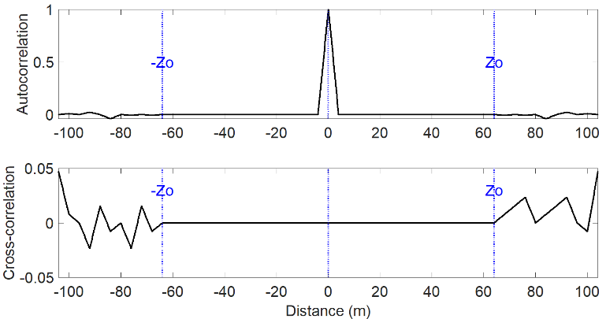

Fig. 2. PACF (top) and PCCF (bottom) of 16 ZCZ codes with length $N=512,$ $Rc = 25 MHz$. The zero-correlation zone width is 16 chips (corresponding to 64 m) long.

ZCZ codes are significant, because by using a ZCZ sequence, (12) becomes

|  |  |
| --- | --- |
| $$R_{rs_{i}^{'}}\left(τ\right)=a_{o}δ_{l}+\sum_{p}{a_{p} δ_{l-p}}$$ | (14) |

where $δ_{l}$ is the Kronecker delta defined as

|  |  |  |
| --- | --- | --- |
| $$δ_{l}=\left\{\begin{aligned}0 \\ 1\end{aligned}\right.$$ | if $l≠0$ | (15) |
| if $l=0$ |

In this case, both self-interference and mutual interference are eliminated. The drawback of these sequences is the tradeoff between the zero-correlation zone width and the number of sequences available for a specific sequence length. For more details, refer to Table 1 in [19]. Consequently, ZCZ sequences are more suitable for distributed diagnostic systems where the number and location of sensors are judiciously chosen.

# Experimental Validation

To validate the effectiveness of properly chosen ZCZ codes for distributed sensing, we measure reflection from a simple Y-shaped wire network with a single sensor and code. We then add up to 15 simultaneous codes as interferers. We compare *m-*, Gold, and ZCZ codes.

1) Test Setup

We use a Rohde & Schwarz MXO5 oscilloscope with two waveform generators, as shown in Fig. 3. The function generators in this scope output predefined waveforms at 625 Msample/s, while its arbitrary waveform generators output user-defined waveforms with rates up to 312.5 Msample/s. We generated a signal sequence using MATLAB and uploaded it to the arbitrary waveform generator. The signal was captured by using one of the input channels (8 channels) with input impedance that can be set to either 50 Ω or 1 MΩ. An example of 30 chips of a 25 MHz m-sequence signal are shown in Fig. 3. The theoretical and measured values (using a direct connection between generator and scope) are compared.



Fig 3. First 30 chips of the 25 MHz m-sequence comparing the ideal (theoretical) and measured (generated) time domain values.

Three RG-58 coaxial cables with characteristic impedance 50Ω are used to form the Y-network. Generator 1 (Gen1) is connected at A to a 30.5 m cable, which connects at B to a T-junction of 13.7 m and 31.2 m cables. The BNC T-adapter at A also connects channel 1 of the oscilloscope. The signals are generated based on sequences uploaded from MATLAB. These are either STDR or SSTDR. The STDR is a square wave modulated by a sequence (as in (1), shown in Fig. 3), and the SSTDR is a sine wave modulated by the STDR signal. The sequences are of length $N=511$ for *m-* and Gold sequences, and $N=512$ for ZCZ sequences. The chip rate is $25 MHz,$ giving a chip duration of $T_{c}=40 ns$. The sequence is up-sampled by a factor of $N_{s}=10,$ so the sample rate is $250 MHz$*.* The highest sampling rate available for this generator is slightly above $300 MHz$. The reflected signals come back to the scope through the T-junction at A. Then the signals are downloaded and processed (cross-correlated with the incident signal) using MATLAB.

Fig. 3. Experimental setup for simultaneous diagnosis using SS/STDR distributed reflectometry.

**A**

**B**

**Open circuit**

**D**

$$30.5m$$

$$13.7m$$

$$31.2m$$

**Gen1**

**C**

**Matched**

**Open Short**

**Gen2**

**Scope**

2) Single-point diagnosis of wire network

In this section, we consider reflection from the wired network in Fig. 3 using only Gen 1 at A, transmitting an *m*-sequence. We expect *m*-sequences to be optimal for single-point diagnostic systems. The $25 MHz$ STDR *m*-sequence has a length $N=511$ and is up-sampled to $250 MHz$. The distance from Gen1 is calculated as *d=VOP/(2 x time)*, where *VOP= $2 x{10}^{8} m/s$* is 2/3 the speed of light. The factor of two in the denominator comes from the wave traveling to the end of the cable and back. The signal amplitude is $62.5 mV$. This was chosen, so that the sum of this signal plus (in later sections) 15 additional sequences representing additional distributed sensor units (and consequent interferers) would remain under the maximum allowable voltage of the function generator (5 Vpeak). Increasing the amplitude of the test signal will raise the correlation peak amplitudes, however, the overall shape of the response remains unchanged. The test signal is a square wave modulated by a sequence, with each chip having a duration of $T_{c}=40 ns$, which corresponds to sampling distance of $8 m$. The sequence is up-sampled by a factor of $N_{s}=10$ resulting in a sample width of $4 ns$ corresponding to a sampling distance of $0.8 m$.

The diagnosis of the wired network can be in either continuous mode, where the periodic STDR signal transmits continuously and is correlated continuously, or in non-continuous mode, where only one period of the *m*-sequence is used. A detailed analysis can be found in [18]. The correlated reflection signatures of the wire network in Fig. 3 to the two diagnostic modes are plotted in Fig. 4.

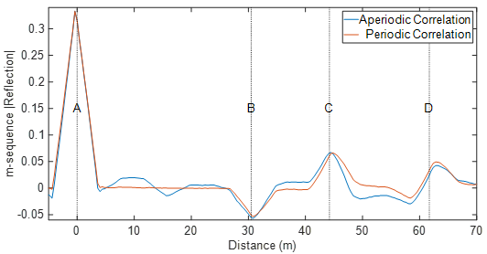

Fig. 4. STDR response from a Y-shaped wire network using non-continuous (aperiodic) and continuous (periodic) monitoring with an *m*-sequence. The letters on the peaks correspond to the locations noted in Fig. 3.

The peaks in Fig. 4 are from the impedance discontinuities in the wired network. The first peak (A at 0 m) corresponds to the T-junction connecting Gen1 and the scope to the first cable. The magnitude of a reflection at a T-junction between cables of equal impedance is 1/3, so we have used this value to normalize the correlation magnitude, giving the reflection amplitudes (|Reflection|) shown in Fig. 4 and all remaining figures in this paper. The second peak (B at $30.5 m)$ is from the junction (B) where 1/3 of the signal energy is reflected. Peak C (at 44.2 m) is from the end of the 13.7 m cable. Peak D (at $61.7m$) is from the end of the 31.2 m cable. The response using periodic correlation is smoother than the one using aperiodic correlation, which is due to the continuous nature of the diagnostic system. When the periodic correlation is performed, only the even PACF (12) is computed. For a non-continuous diagnostic system, another type of correlation function called the odd periodic correlation function (OPACF) must also be considered. The effect of the OPACF can be seen in the fluctuation of the response using aperiodic correlation.

## View from Generator 1

The periodic correlated reflection response of the Y-shaped wire network in Fig. 3 using a single generator (Gen1 at A) is shown in Fig. 5. The generator is matched (50Ω), the end of 31.2m cable is an open circuit, and the end of the 13.7 cable is measured with three different loads -- matched (50 Ω), open, and short. Gen1 injects STDR signals based on *m*-, Gold, or ZCZ sequences. The test signal of amplitude is $62.5 mV$ is injected continuously, forming a periodic signal. The combination of this incident and associated periodic reflection signals are collected by the scope. This is correlated with the incident signal offline, which is obtained by connecting Gen1 directly to the scope. The correlated signals are shown in Fig. 5. All sequence types perform well in this case with no interference. The *m*-sequence is the best, as expected.

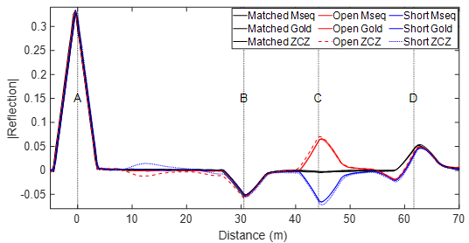

Fig. 5. STDR response of the Y-shaped wire network in Fig. 3 using *m-*, Gold, or ZCZ sequences applied at Gen1 at A. The end of the 13.7m cable is matched, open, or short. Gen2 is not active.

The peak at A, seen in Fig. 5 at $x=0$, is caused by the reflection at the first T-junction. The second peak (B) is from the second T-junction used to form the Y-network at 30.5 m. Peak C from the end of the 13.7m cable appears at 44.2 m, the combination of the 30.5m and 13.7m cables. The positive peak at C is from the open, the negative from the short, and the lack of peak from the matched load. Finally, peak D from the open end of the 31.2m cable appears at 61.7m. Additional smaller reflections (not shown) follow, from multiple reflections within the network. A similar correlated reflection response from SSTDR is shown in Fig. 6.

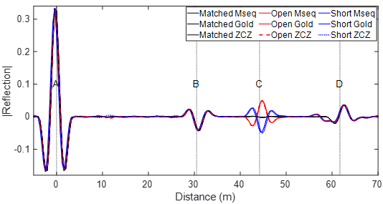

Fig. 6. SSTDR response of the Y-shaped wire network in Fig. 3 using *m-*, Gold, or ZCZ sequences at Gen1. The end of the 13.7m cable is matched, open, or short. Gen2 is not active.

## View from Generator 2

In the previous section, from the point of view of only Gen1 at A, we cannot determine which peak (at $30.5 m$ and $61.7m$) corresponds to the end of which cable branch. To remove this ambiguity, another sensor (Gen 2 at C) is used. For the network in Fig. 3, Gen1 at A is replaced by either an open, short, or matched load, and the injected signal is from Gen2 at C (which is connected to the scope through a T-junction). The correlated reflection is shown in Fig. 7. As in Fig. 5, the peak at C (*x=0)* is caused by the T-junction between Gen2, the scope, and the13.7m cable. The peak at B is caused by the T-junction between all three cables. At AD (44.2 m),we see a positive peak corresponding to reflections that add up from open circuits at A and D.

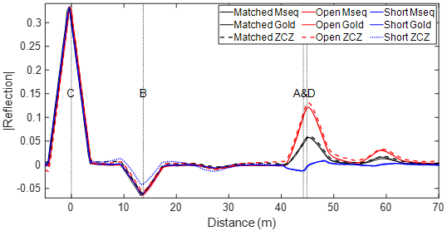

Fig. 7. STDR response of the Y-shaped wire network in Fig. 3 using Gen2 to apply *m-*, Gold, or ZCZ sequences at C, where the scope is also connected. The cable at A is matched, open, or short.

3) Distributed diagnosis of wire network

We now evaluate a simultaneous and distributed diagnosis of the network. Gen1 at A sends one STDR signal while Gen2 at C sends additional signals to simulate multiple distributed sensors on other parts of the network. With all sensors working simultaneously, signals from Gen2 cause some interference with those from Gen 1, which we evaluate in this section.

## View from Generator 1

The correlated reflection signatures measured at Gen1 (originally seen in Fig. 5) are shown in Fig. 8. Additional signals (interferers) are sent into the system by Gen2. Up to 15 additional signals (each with amplitude 62.5mV) are added up, slightly delayed from each other, and sent into the system by Gen2 at C. Significant measurement interference is seen for *m-* and Gold sequences, but little interference is seen for ZCZ sequences. It is important to note that the amplitude of the signals was chosen so that when constructive interference (the sum) of all 15 sequences occurs, which will give 15 times the original amplitude, the function generator would not clip this total amplitude. Also, the reason sequences were added up out of sync by portions of a chip, is that there is more interference from this than from sequences that are delayed by an integer number of chips.

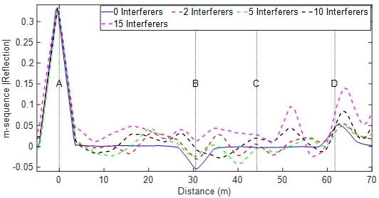

(a)

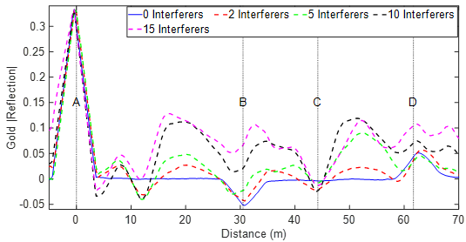

(b)

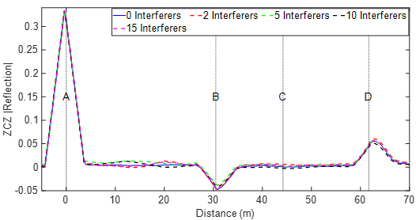

(c)

Fig. 8. STDR response of the Y-shaped wire network in Fig. 3 using Gen1 (at A). Gen2 (at C) is matched. Gen2 injects up to 15 interference signals that are (a) *m-*, (b) Gold, or (c) ZCZ sequences.

The interference signals have a significant impact on the diagnostic capability of the system, as shown in Fig. 8. Even two interferers are enough to cause ambiguity when *m-* and Gold sequences are used. ZCZ sequences, with their ideal correlation properties, are not impacted by other interferers in this time/distance zone. The normalized interference error, illustrated in Fig. 8, is defined as the average difference between measurements with 0 and 15 interferers across the 0–70 m range, normalized by the magnitude of the peak response at point A. For m-sequences, Gold codes, and ZCZ sequences, the normalized interference error values are [insert values], [insert values], and [insert values], respectively. Similar trends are observed for SSTDR measurements in Fig. 9, where m- and Gold sequences exhibit normalized interference errors of [insert values] and [insert values], respectively, while ZCZ sequences show significantly lower error at [insert value].

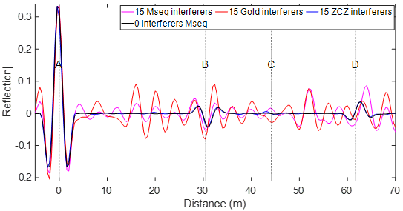

Fig. 9. SSTDR response of the Y-shaped wire network in Fig. 3 is applied at Gen1(at A). Gen2 (at C) is matched and injects 15 interference signals that are *m-*, Gold, or ZCZ sequences.

## View from Generator 2

We now switch our view of the network from A to C. Gen2 (C) injects an STDR signal, and Gen1 (A) injects 5 interference signals. The reflection response is shown in Fig. 10.

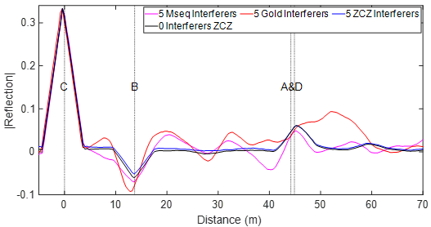

Fig. 10. STDR response of the Y-shaped wire network in Fig. 3. The signal is applied at Gen2 (at C). Gen1 (at A) is matched and injects 5 interference signals that are *m-*, Gold, or ZCZ sequences.

# Simulation Results

The results in section IV demonstrate the relative interference of *m-,* Gold, and ZCZ sequences for distributed sensing. The specific examples were done at 25 MHz, where the 16 ZCZ sequences 512 chips long have a zero-correlation zone of 64 m. We would like to be able to extend these results to other applications, with different frequencies, sampling rates, code lengths, zero correlation zones, numbers of interferers, etc. For this purpose, we have developed a simulation tool. A bounce diagram is used to determine the expected magnitudes and time delays of reflections and transmission within the wire network. These magnitudes and time delays are used to determine an expected correlation signature for each reflection, and then all reflections are added to create the total correlation signature. For the wire network in Fig. 3 with Gen 1 transmitting a single sequence at A and Gen 2 transmitting 15 interfering signals at C, the correlated reflection response is shown in Fig. 11 for *m*-, Gold, and ZCZ sequences. This is comparable to measured data shown in Fig. 5 with C an open circuit or high impedance generator. The various levels of interference for the different sequence types are comparable to Fig. 8 with 15 interferers.

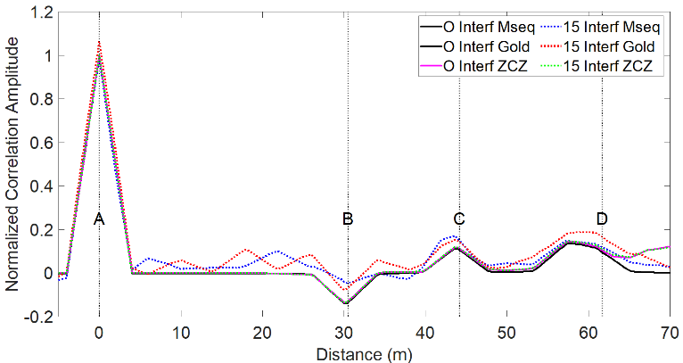

Fig. 11. Diagnosis of Y-shaped wire network using STDR using *m-*, Gold, or ZCZ sequences. Gen. 1 (at A) is testing, and Gen. 2 (at C) injects 15 interference signals.

# Discussion and Conclusion

This paper concentrates on enabling distributed sensing and diagnosis of branched wire networks using spread spectrum and sequence time domain reflectometry (S/SSTDR) with zero-correlation codes (ZCZ). The advantage of these sequences is that they have literally zero correlation over a specific zone (in time or space) that can greatly improve testing accuracy. This has been previously introduced in [18], [19], [20]. In this paper, we validated these results with measurement on a Y-shaped branched network. We compared *m*-, Gold, and ZCZ sequences to determine how much interference will be seen from one test sequence with up to 15 interferers. As expected, we saw that *m*-sequences are very effective (have low self-interference) when only one sequence is used. This would be ideal for testing from a single point, with no additional interference present in the system. However, in distributed sensing, where testing is done from multiple locations to improve the diagnostic options for the system, the interference from these multiple sequences testing simultaneously is substantial and problematic for both *m*- and Gold sequences. The ZCZ sequences show near-perfect zero-correlation over their expected zones, thus enabling much better test results. Outside of their zone, the interference is significant, so these sequences should be carefully designed for each application (frequency, zone length, and desired number of available sequences) to ensure ideal testing. The zone length ($Z_{o}$), sequence length (*N* chips), and number of available ZCZ sequences (*M*) are related as

|  |  |
| --- | --- |
| $$Z_{o}=\frac{N}{M}-1$$ | (16) |

In addition to validating the performance of the ZCZ sequences on a simple Y-network, a numerical simulation code was developed to allow us to consider more complex networks and different sequence parameters for other applications. If we want to work on a smaller length system, we can increase the frequency and decrease the zero-correlation zone time $Z_{o} (s)$. The zone length in seconds is $Z_{o} (s) = Z_{o} Tc$, and in meters is $Z_{o}(m) = Z_{o}(s) VOP$. This means that the zero-correlation zone, in seconds or meters, scales inversely with frequency. For example, if we scale the 25 MHz ZCZ sequence set—with 16 sequences that are 512 chips long, as used in the sections above—to the same set of sequences at 4 GHz, the zone in meters is $Z_{o}\left(m\right)=0.8 m$. This is an appropriate size for many types of imaging systems, such as microwave-based breast cancer detection.

These results demonstrate and validate the effectiveness of using ZCZ sequences for distributed testing with multiple STDR or SSTDR sensors operating simultaneously to assess a system from multiple vantage points.

Disclosure

Dr. C. M. Furse is a co-founder of LiveWire Innovation, Inc. that is commercializing SSTDR technology, and therefore she is disclosing a financial conflict of interest.

Acknowledgment

The authors gratefully acknowledge financial support for this research by the Fulbright U.S. Scholar Program, which is sponsored by the U.S. Department of State. Its contents are solely the responsibility of the author and do not necessarily represent the official views of the Fulbright Program or the Government of the United States. The authors would also like to thank Rhode-Schwarz for loaning the MXO5 oscilloscope.

References

[1] C. M. Furse, M. Kafal, R. Razzaghi, and Y.-J. Shin, “Fault Diagnosis for Electrical Systems and Power Networks: A Review,” *IEEE Sensors Journal*, 2020.

[2] A. Lelong, L. Sommervogel, N. Ravot, and M. O. Carrion, “Distributed reflectometry method for wire fault location using selective average,” *IEEE sensors journal*, vol. 10, no. 2, pp. 300–310, 2009.

[3] C. Lo and C. Furse, “Modeling and simulation of branched wiring networks,” *Applied Computational Electromagnetics Society Journal*, vol. 23, no. 2, p. 143, 2008.

[4] F. Auzanneau, N. Ravot, and L. Incarbone, “Chaos time domain reflectometry for online defect detection in noisy wired networks,” *IEEE Sensors Journal*, vol. 16, no. 22, pp. 8027–8034, 2016.

[5] Z. Zhou, T. Li, S. He, J. Liu, L. Meng, and G. Lu, “A Greedy Algorithm-based Cable Fault Diagnosis Method for Avionics Systems,” in *2022 IEEE International Conference on Sensing, Diagnostics, Prognostics, and Control ( SDPC)*, Aug. 2022, pp. 393–398. doi: 10.1109/SDPC55702.2022.9915971.

[6] C. Lo, K. Nagoti, A. W. Mahoney, Y. Chung, and C. Furse, “Detection and Mapping of Branched Wiring Networks from Reflectometry Responses,” presented at the Joint FAA/DoD/NASA Conference on Aging Aircraft, Palm Springs, CA, Feb. 2005.

[7] X. Liu, M. Qiu, M. Wei, and D. Cao, “Ground Fault Localization of Branched Wire Network using Reverse Image Search,” in *2022 IEEE Energy Conversion Congress and Exposition (ECCE)*, Oct. 2022, pp. 1–6. doi: 10.1109/ECCE50734.2022.9947616.

[8] T. Kakiuchi, K. Iokibe, and Y. Toyota, “Detection Sensitivity Improvement in Sequence Time Domain Reflectometry by Removing Pulse Reflected at Nodes in Bus Network,” in *2024 IEEE Joint International Symposium on Electromagnetic Compatibility, Signal & Power Integrity: EMC Japan / Asia-Pacific International Symposium on Electromagnetic Compatibility (EMC Japan/APEMC Okinawa)*, May 2024, pp. 225–228. doi: 10.23919/EMCJapan/APEMCOkinaw58965.2024.10585058.

[9] S. J. Chang and J. B. Park, “Multiple Chirp Reflectometry for Determination of Fault Direction and Localization in Live Branched Network Cables,” *IEEE Transactions on Instrumentation and Measurement*, vol. 66, no. 10, pp. 2606–2614, Oct. 2017, doi: 10.1109/TIM.2017.2700178.

[10] C.-K. Lee and S. J. Chang, “A Method of Fault Localization Within the Blind Spot Using the Hybridization Between TDR and Wavelet Transform,” *IEEE Sensors Journal*, vol. 21, no. 4, pp. 5102–5110, Feb. 2021, doi: 10.1109/JSEN.2020.3035754.

[11] X. Zhang, M. Zhang, and D. Liu, “Reconstruction of faulty cable network using time-domain reflectometry,” *Progress In Electromagnetics Research*, vol. 136, pp. 457–478, 2013.

[12] W. B. Hassen, F. Auzanneau, L. Incarbone, F. Peres, and A. P. Tchangani, “Distributed sensor fusion for wire fault location using sensor clustering strategy,” *International Journal of Distributed Sensor Networks*, Jan. 2015, doi: 10.1155/2015/538643.

[13] W. B. Hassen, M. Kafal, E. Cabanillas, and J. Benoit, “Power cable network topology reconstruction using multi-carrier reflectometry for fault detection and location in live smart grids,” in *2018 Condition Monitoring and Diagnosis (CMD)*, IEEE, 2018, pp. 1–5.

[14] M. K. Smail, T. Hacib, L. Pichon, and F. Loete, “Detection and Location of Defects in Wiring Networks Using Time-Domain Reflectometry and Neural Networks,” *IEEE Transactions on Magnetics*, vol. 47, no. 5, pp. 1502–1505, May 2011, doi: 10.1109/TMAG.2010.2089503.

[15] C. Chen, Q. Guan, Q. Guan, X. Jin, and Z. Shi, “Soft Fault Location and Imaging Using Residual Voltage Inversion in Cable Networks,” *IEEE Transactions on Instrumentation and Measurement*, vol. 74, pp. 1–16, 2025, doi: 10.1109/TIM.2025.3542111.

[16] M. Kafal, N. Grégis, J. Benoit, and N. Ravot, “An Effective Method Based on Time Reversal and Optimization Techniques for Locating Faults on Power Grids,” *IEEE Sensors Journal*, vol. 21, no. 2, pp. 1092–1099, Jan. 2021, doi: 10.1109/JSEN.2020.3000301.

[17] S. Kingston *et al.*, “A SSTDR methodology, implementations, and challenges,” *Sensors*, vol. 21, no. 16, p. 5268, 2021.

[18] M. Addad and A. Djebbari, “Spread Spectrum Sensing Based on ZCZ Sequences for the Diagnosis of Noisy Wired Networks,” *IEEE Sensors Journal*, vol. 21, no. 2, pp. 914–920, 2020.

[19] M. Addad and A. Djebbari, “Simultaneous multiple cable fault locating using zero correlation zone codes,” *IEEE Sensors Journal*, vol. 21, no. 2, pp. 907–913, 2020.

[20] M. Addad and A. Djebbari, “Spread spectrum reflectometry for the simultaneous diagnosis of shielded cable bundles,” *Nondestructive Testing and Evaluation*, vol. 39, no. 4, pp. 939–953, 2024.

**Mouad Addad** received his Ph.D. degree in Telecommunications from Djillali Liabes University of Sidi Bel Abbes, Algeria, in 2018. He joined the Telecommunications Department at the same University in 2018 where he is currently an Associate Professor. From 2017 to 2018, he was a visiting Ph.D. student at the Institute of Electronics, Microelectronics, and Nanotechnology (IEMN) in Valenciennes, France. In September 2024, he joined the Electrical and Computer Engineering Department at the University of Utah as a Visiting Scholar. His research interests include sequence design for communication systems, multiple access spread spectrum systems, channel estimation, and electrical system diagnosis using reflectometry measurements.A person smiling at the camera

**Ali Djebbari** received his Ph.D. degree in Signal Processing from the University of Sciences and Technology of Oran (USTO), Algeria, in 1997. In 1991, he joined the Djillali Liabes University, as an Assistant Professor, became a Lecturer in 1997, and was promoted to Full Professor in 2003. He was promoted to Distinguished Professor in 2025. Since 2000, he has been the Director of the Telecommunications and Digital Signal Processing Laboratory. He is currently with the Telecommunications Department, Faculty of Electrical Engineering, at Djillali Liabes University. His research interests include signal processing for telecommunications, free-space optical and fiber-optic systems, visible light communications, and diagnostic methods for wired and optical networks.A person wearing glasses and a black shirt

**Evan Benoit** received a B.S. degree in nuclear engineering technology from Excelsior College, Albany, NY, USA, in 2015, a B.S. and M.S. degrees in electrical and computer engineering, and a Ph.D. degree in electrical engineering from the University of Utah, Salt Lake City, UT, USA, in 2020 and 2023, respectively. His focus of study was on electromagnetics and transmission lines. From 2005 to 2015, he was a Submarine Nuclear Field Electrician’s Mate with the U.S. Navy, in Philadelphia, PA, USA. He is working as a Research Assistant at the University of Utah, during the summer of 2018. After completing the Ph.D. degree, he became a Lecturing Instructor with the University of Utah Asia Campus in Seoul, Incheon, South Korea, where he teaches physics and electrical and computer engineering courses in the first two years of the ECE undergraduate program. His research explores the applicability and validation of spread spectrum time-domain reflectometry for measuring complex impedances and reflection coefficients on transmission lines.

**Cynthia M. Furse** (M’85–SM’99–F’08) is a Distinguished Professor of Electrical and Computer Engineering at the University of Utah. She applies electromagnetics to sensing and communication in complex lossy media such as the human body. She is a Fellow of the IEEE, the National Academy of Inventors, and the Applied Computational Electromagnetics Society and has received numerous teaching and research awards including the 2020 IEEE Chen To Tai Distinguished Educator Award. A close-up of a person smiling
